Part VI Writing
- Write a short passage of about 100 words to describe the picture. Some useful expressions are provided to help you. Start the passage with “Sandra was writing a letter to decline Mary’s invitation to her birthday party.”
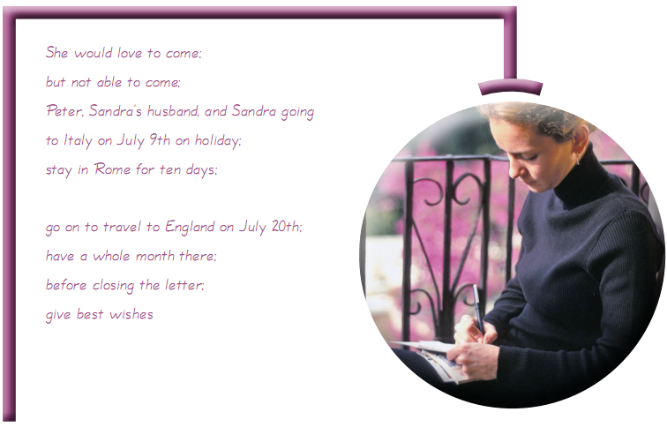
Sandra was writing a letter to decline Mary’s invitation to her birthday party. She would love to come, but unfortunately, she was not able to. She had to decline Mary’s invitation by saying, “Thank you for the invitation to your birthday party. We’d love to come but I’m afraid that Peter and I are going to Italy on holiday on July 9th. We’ll stay in Rome for ten days and then go on to travel to England on July 20th, and we’ll have a whole month there.” Before closing the letter, Sandra asked Mary to give her best wishes to her family.

- Write a short email passage of about 100 words to describe the picture below. Some useful expressions are provided to help you. Start the passage with “Email allows people around the world to communicate cheaply, quickly and frequently.”
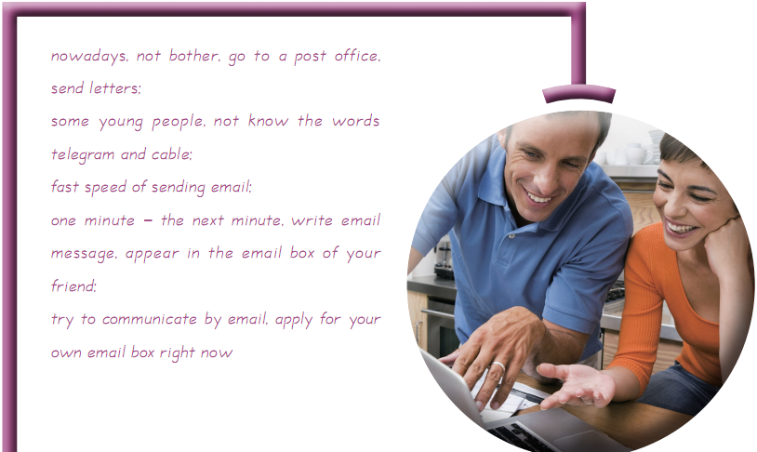

E-mail allows people around the world to communicate cheaply, quickly and frequently. Nowadays you don’t have to bother to go to a post office to send your letters. Some young people even do not know the words telegram and cable.
The speed e-mail is sent is enormously fast. One minute you were still writing the message, the next minute it would appear in your friend’s e-mail box.
Have you ever tried to communicate with your friends by e-mail? If not yet, why not apply for your own e-mail box right now?

3. Write a short passage of about 100 words to describe the area code map blow. Some useful words and phrases are provided to help you. Start the passage with “The United States is divided into telephone dialing areas.”
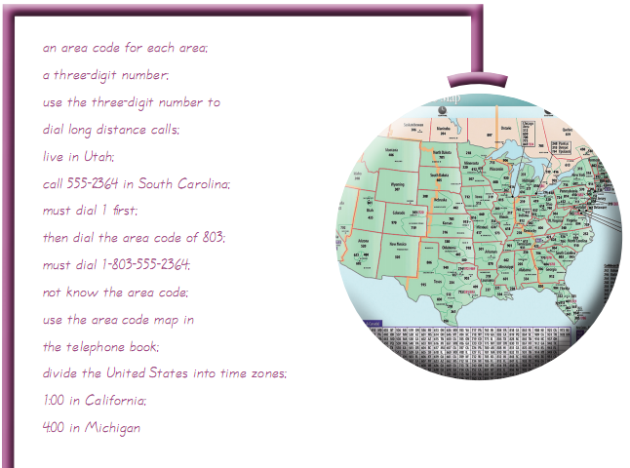

The United States is divided into telephone dialing areas. Each area has an area code. It is a three-digit number. You use this number to dial long distance calls. For example, you want to call 555-2364 in South Carolina but you live in Utah, you must dial 1 first and then the area code. It is 803. So you must dial 1-803-555-2364.
When you do not know the area code, you can use the area code map in the telephone book. The map divides the United States into time zones. Notice that when it is 1:00 in California, it is 4:00 in Michigan.

4. Write a letter of complaint of about 120 words to describe the picture below. Some useful expressions are provided to help you. You may start the passage with the sentence “On July 16 my friends and I arrived at your inn, hoping to spend an enjoyable weekend.”
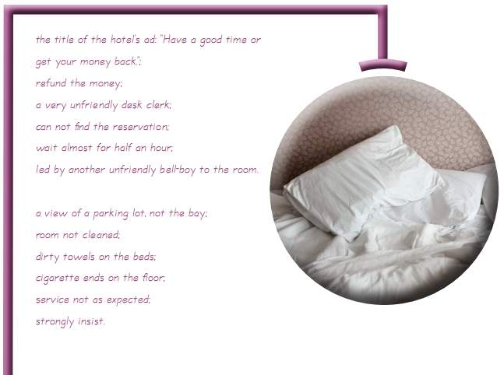
Dear Madam or Sir,
On July 16 my friends and I arrived at your inn, hoping to spend an enjoyable weekend. Since your ad says “have a good time or get your money back”, I am requesting that you refund our money.
From the moment we arrived, there were problems with the service. First, a very unfriendly desk clerk couldn’t find our reservation. After waiting for almost half an hour, we were led by another unfriendly bell-boy to our room. The room, which had a view of a parking lot instead of the bay, had not yet been cleaned, so we found dirty towels on the beds and cigarette ends on the floor. This was not the weekend we had been looking forward to.
Service at your inn was not as I expected. So I strongly insist that you give me my refund.
Yours sincerely,
XXX (Your signature)

5. Write a short passage of about 100 words to describe the picture below. Some useful expressions are provided to help you.
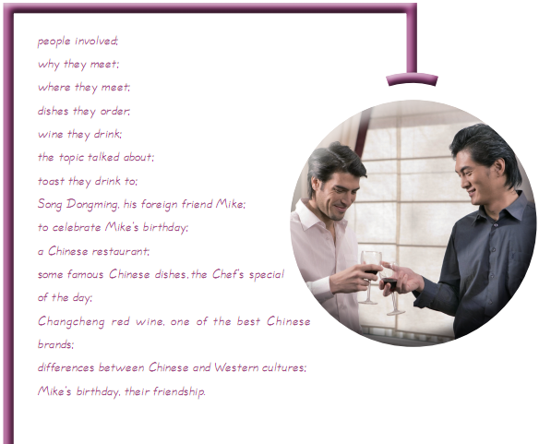
Song Dongming and his foreign friend, Mike, are having dinner in a Chinese restaurant to celebrate Mike’s birthday. Mike often eats Chinese food and enjoys it very much. They have ordered several famous Chinese dishes. They have also ordered the Chef’s special of the day. The wine they are drinking is Changcheng red wine, which is one of the best Chinese brands. While drinking and eating, they talk about the differences between Chinese and Western food cultures. In the end they drink a toast to both Mike’s birthday and their friendship.

